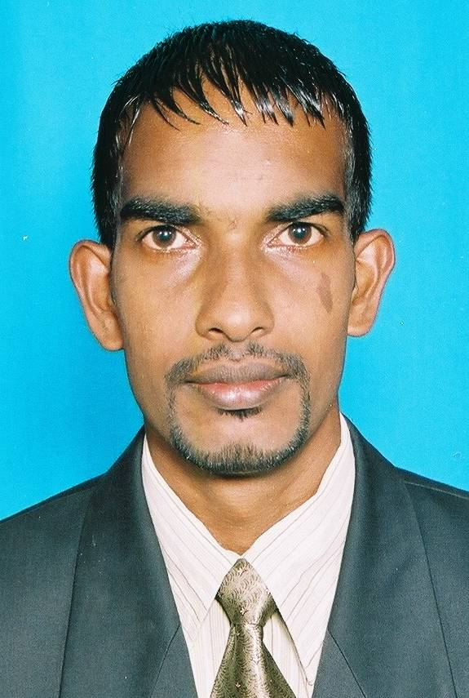**CURRICULUM VITAE**

**CONTACT DETAIL**

**Full Name :** Aravandi Pillai Sivakumaran

**Address :** No. 78, Main Street, Watagoda. Srilanka.

**Contact No :** +94774569363, +94757223882 **Sex :** Male

**Email ID** **:** [sivasl78@yahoo.com](mailto:sivasl78@yahoo.com) **Religion :** Hindu

**Date of Birth :** August 23rd, 1978 **Height :** 5’.9”

**Civil Status :** Bachelor **Nationality :** Indian Tamil

**EDUCATIONAL QUALIFICATION**

1. **Completed G.C.E (A/L) in the year 1999 in the Stream of Commerce**

The subjects studied are as follows:

* 1. Economics 2). Business study 3). Accounting 4). Tamil

1. **Passed G.C.E (O/L) in 1996**

**Subjects Results**

English C

Agriculture C

Social Studies C

Religion C

Mathematics S

Tamil S

**3.** Followed Daham Education up to Grade-4 during the Period of 1991-1994, at

Sri Visuddhananda Daham Pasal, Sudharmaramaya Pansala, Watagoda. (Sinhala Medium)

**OTHER QUALIFICATIONS**

* Passed with 62 marks for **General Knowledge** at Plantation Sector Teaching Examination in year 2005
* Passed 65 marks for **English Teaching** Examination in year 2005; Conducted by “Excellence, Centre for English Language Studies, Riverdale Road, Kandy.”
* Successfully completed in credit level one-year English medium ‘**Secretarial Practice’** Course at Vocational Training Authority of Srilanka, Hatton. Offering the following subjects:
  + Shorthand, Typing, English, Computer, Basic Accounts, Office Management, Receptionist
  + Official skills : Such as implementing 5S methods,

Maintaining Filing Systems and other Secretarial duties

* Excellent communication skills both oral and written in the following ‘**Languages’**
  + English, Tamil, Sinhala
  + Russian (Learning by self studies) only for talking
  + I can converse well in Dhivehi (Maldivian Language)
* Participated in a workshop on ‘**Empowerment of Sri Lankan Youth for Protection of Representative Democracy’** for two days at SIDA Resource Centre Hatton

**WORK EXPERIENCE**

* **Position :** **Accounts/Reservation Executive** **Period :** **November 2012 to Present**

**Company :** **Divyaa Lagoon Resort, Kalpitiya Srilanka**

* Making reservation, coordinating with room boys to fix the rooms (single, double, triple).
* Fixing rates for walking customer as promotional offer.
* Preparing guest bills, cashiering and making discounts to promote the business according to the situation.
* Preparing sales register and fixing the service charge.
* Preparing monthly attendance register and making salary payments.
* Purchasing and making payments for various requirements.
* Responding the calls from the in-house guests and other tour operators, agents, etc,
* **Position :** **Day Auditor** **Period :** **October 2011 to October 2012**

**Company :** **Olhuveli Beach & Spa Resort. Maldives.**

* Daily checking guest registration cards, invoice vouchers and making reservation invoices Including checking the room category, meal plan, room nights, bed tax and room income correctly charged or not.
* Preparing monthly invoice summary report
* Preparing and checking supply invoices for settle the payments
* Manual bills posting, editing and checking for the particular outlets
* Posting guest, complimentary and third party telephone charges
* Answering the calls, filing the reports, solving problems.
* Handling other team members’ duties when are they on off, such as Staff Shop keeper, Accounts Assistant, Night Auditor, Chief Accountant.
* **Position**  : **Night Auditor and Billing Clerk** **Period: May 2009 to July 2010**

**Company** : **Kuramathi Island Resort. Maldives.**

* Checking bills, Guest payment details, staff telephone report and preparing staff telephone bills in the month end.
* Handling the problem in relation to complaints such as discounts, payment refusal of the guests and other problems from the reception and outlet
* Handling other’s duties during the absence of Data entry clerk, Accounts executive, Night auditors and other staffs.
* Preparing DMI Report - Daily Management Information (Resort Daily Revenue Report)
* Preparing HODMI Report - Head Office Daily Management Information Report
* **Position** **:** **Account Maintainer** **Period:** **January 2008 to April 2009**

**Company :** **Glory’s. Keizer Street, Colombo-11.Srilanka.**

* Maintaining Accounts and Direct dealing with wholesale customers
* Making sales, Checking daily statements, Delivering goods & other relevant duties
* **Position :** **Administrative Officer** **Period:** **January 2000 to December 2003**

**Company :** **Loyal Academy. Hatton. Srilanka.**

* + Accounts maintenance
  + Organizing Classes, seminars, functions and other programmes
  + Leave approval
  + Record management
  + Computer operating
  + Information services

**COMPETENCIES**

* Able to work long hours, learn fast, fast touching in letter keys & numerical keys
* Working under pressure with minimum supervision and commitment
* Being a good team player and working with multi cultural people
* Able to Handle multi tasks
* Achieve targets
* Implementing new ideas, Using business strategies & Working with creative minds
* Translation abilities in Tamil, English and Sinhala

**EXTRA CURRICULAR AND OHER ACTIVIES**

* I have participated and won prizes in Athletics, Games and Cultural Programmes.
* Special skills in cricket
* Had been as a captain in school and college (V.T.A) cricket team
* Social and cultural activities
* Been a member in resort volley ball & cricket team

**REFEREES**

|  |  |
| --- | --- |
| .Mr. T. V. Marimuthu B.A (Cey.) JPUM  (Former Director of Education for Nuwara Eliya District)  “Siva Illam”, Watagoda. Sri Lanka  009451-2236012 | Mr. S. Selvakumar (Director)  Univenture College International  No. 17/2, D.H.S. Dunbar Road, Hatton. Sri Lanka  0094-71-8078231, 0094-77-3023271 |

Thanks & Regards

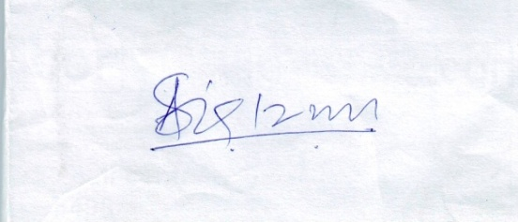

………………………………..

**(A.Sivakumaran)**